**CONWY AND PRESTATYN CIRCUIT**

**INVITES YOU TO**

**A QUIET MORNING**

**EXPLORING**

**SAINT DAVID**

**on**

**SAINT DAVID’S DAY (Saturday March 1st 2025)**

**at**

**SAINT DAVID’S Methodist Church,**

**Craig y Don , LL30 1YY**

**Refreshments from 10am - Start 10.30am - Lunch 12.30am**

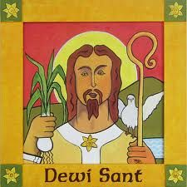

**“DO THE LITTLE THINGS”**

**ALL ARE WELCOME TO COME**

**AND CELEBRATE THIS DAY**

**(A Welsh inspired light lunch will be provided)**

**(If you have any dietary requirements please contact Deacon Denise Creed beforehand)**

**No charge – donations to cover costs appreciated**