For members of our circuit and friends, Please find the latest
CIRCUIT NEWS
Remember that not everyone has access to the internet. Perhaps there are visitors to your church who may not be on our circulation list...
Please feel free to print out a few copies to spread the news!

You are invited to an

Advent Taize Service “Out of the dark into the light”

Ss Peter and Frances
Sunday 15th December 2024 3.15pm - 4.00pm

A practice will be held on Sunday 8th December 2024 after the 11.00am mass.
All welcome

SS Peter & Frances Catholic Church, Plas Avenue, Prestatyn
​Denbighshire. LL19 9NH
​Tel: 01745 854304

Cytûn Policy Newsletter
The latest Cytun Policy Newsletter is now available, which includes many articles, including churches being good for your health, the recent debate about the legalisation of medical assisted dying in England and Wales and the £1.5m which has been announced by Welsh Government to support and
expand safe and warm places for people of all ages to access within
local communities.
Click Here
Circuit Bible Studies

Our ‘Year with Elijah’, that started in the Season of Creation, will continue through Advent. Each week, we will read together 1 Kings 18:41-46; and each week, we will do so bearing in mind a different aspect of Our Calling.
Each week’s Bible Study will be available three times, as shown below. The Zoom details are: https://us02web.zoom.us/j/84967351356?
pwd=NUgaH2eFa7kV1b2oJ5P68sqEJEra6u.1
Meeting ID: 849 6735 1356, Passcode: 210095

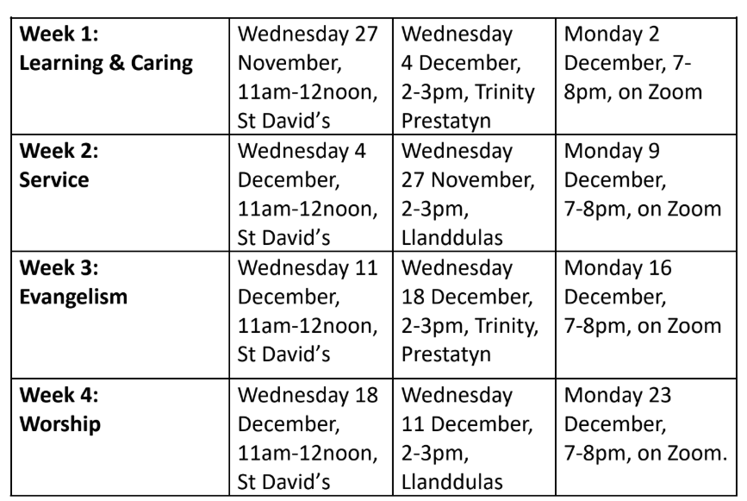

Christian Aid Charity Gifts

Christian Aid charity gifts are a fantastic way to make a real impact around the world to the lives of people living in poverty, whilst also giving a gift of real meaning to a loved one this Christmas.

With the help of Christian Aid's trusted partners, who respond to wherever the need is greatest, your generous gift will make a difference. Choose between an e-card, physical card or print at home card and personalise it with your special message for your recipient. Each card you choose explains more about your selected gift and tells a story about someone – a real person – who's benefited from a similar contribution.
You can shop here now.

A Message from Revd Gethin Rhys, Policy Officer @cytuncymru
Subject: Law Commission Consultation

I attach a draft response from Cytûn to the Law Commission Consultation on burial and cremation law, here and also the first draft of the response by CLAS here, of which many Cytûn churches are members. The intention is for the Cytûn response to be a supplementary response from Wales to the CLAS response. The CLAS response is subject to consultation with CLAS members until December 13, and I hope to circulate the final draft shortly after that date. The closing date for the consultation is January 9 2025, so I would be grateful to receive your comments for the Cytûn response to martinlougher@mac.com (Wales Synod Cymru Property Secretary (DPS) by Monday January 6 at the latest.
You can find the Law Commission consultation documents, including a summary in Welsh, here:https://lawcom.gov.uk/project/burial-and-cremation/

Pob bendith dros yr Adfent – Every blessing for Advent, Gethin

Saturday Space
Zoya and David meet each month to considered aspects of the Christian faith.
21st December  Ruach Retreat  9.45am -12.30pm | If you would like to join David and Zoya, please book your date(s) by email or phone.  Phone: 01492 622279. Email: dray1@btinternet.com
Weekly Circuit Prayer Gatherings
All welcome at all meetings
Tuesday | Llanddulas 10.30am
Tuesday | Conwy 11.45am
Wednesday | St. Davids 11.00am
Thursday | Old Colwyn 10.30am
Friday | St Johns Llandudno 9.30am
Whole Circuit Prayer Breakfast Old Colwyn Saturday 25th January 9.30am

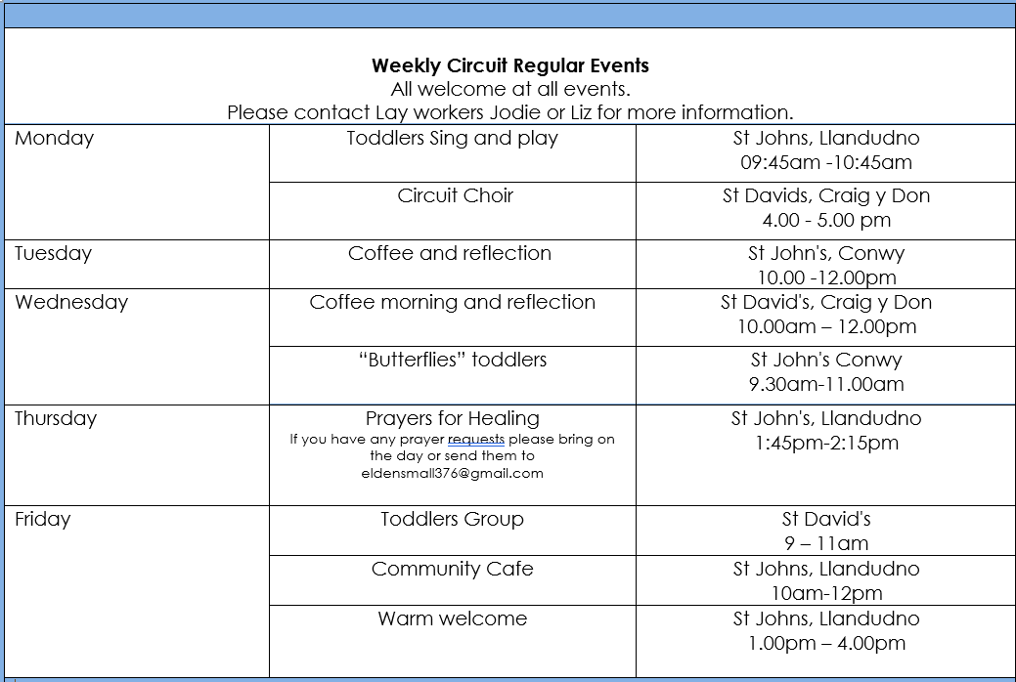

Podcasts, Websites, Newsletters & Publications that may be of interest.. (*=Newly updated)
The Methodist Church | Click here to visit.
Our Circuit website | Click here to Visit
Methodist Property Matters | Click here to Visit
CTBI - Churches together in Britain and Ireland  Serving the churches of Britain and Ireland on the shared journey towards full visible unity in Christ. | Click here to visit.
All We Can - An international relief and development movement, rooted in the Christian faith. Together, we're finding solutions to poverty. | Click to visit
Cytûn - Churches together in Wales website | See link in text above
The Well - For children, youth, schools and family workers | Click here to visit
JPIT - Joint Public Issues Team (Churches working for Peace and Justice) | Click here to visit

